Row Level Security

Row-level security (RLS) with Power BI can be used to restrict data access for given users.

RLS only restricts data access for users with ****Viewer**** permissions. It doesn't apply to Admins, Members, or Contributors.

Configure RLS

1. Define Roles and Rules in the Power BI Desktop.

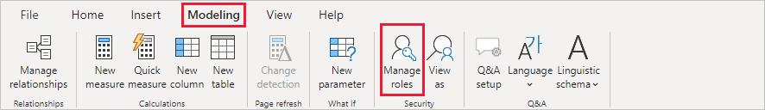

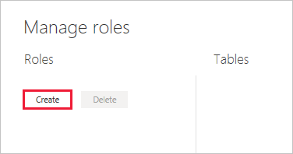

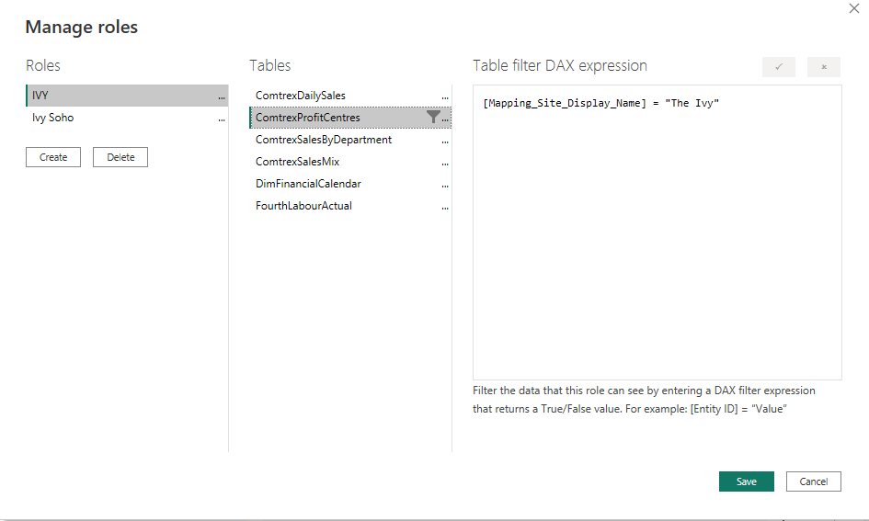

## **enhanced row-level security editor (Preview)**

Enable the preview by going to Files > Options and Settings > Options > Preview features and turn on “Enhanced row-level security editor”.

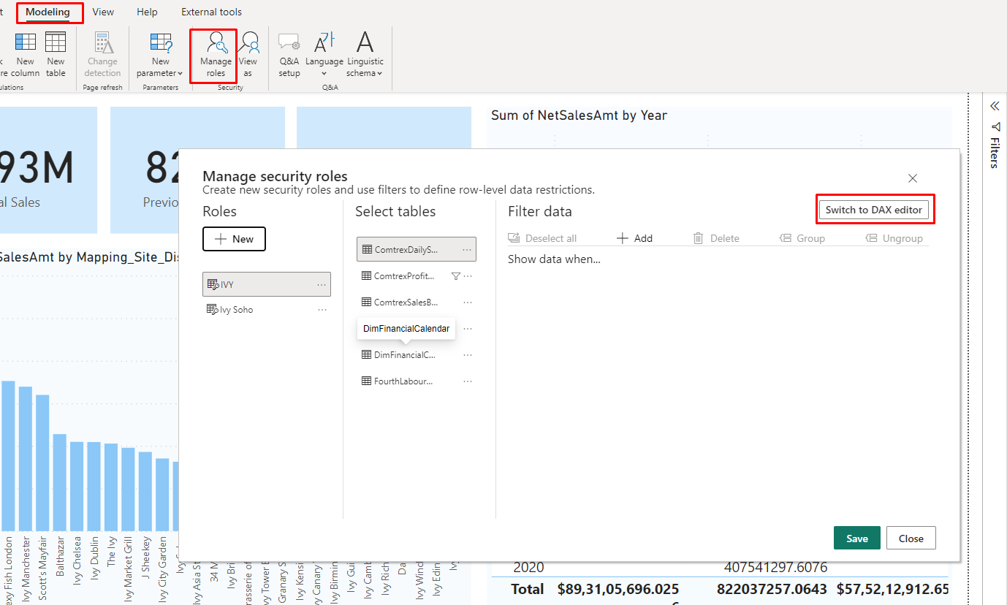

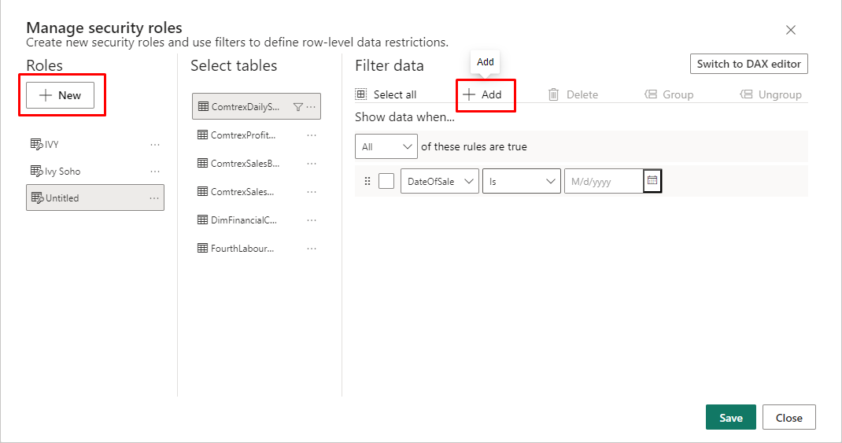

1. After you've created your roles, test the results of the roles within Power BI Desktop.
2. From the ****Modeling**** tab, select ****View as****.

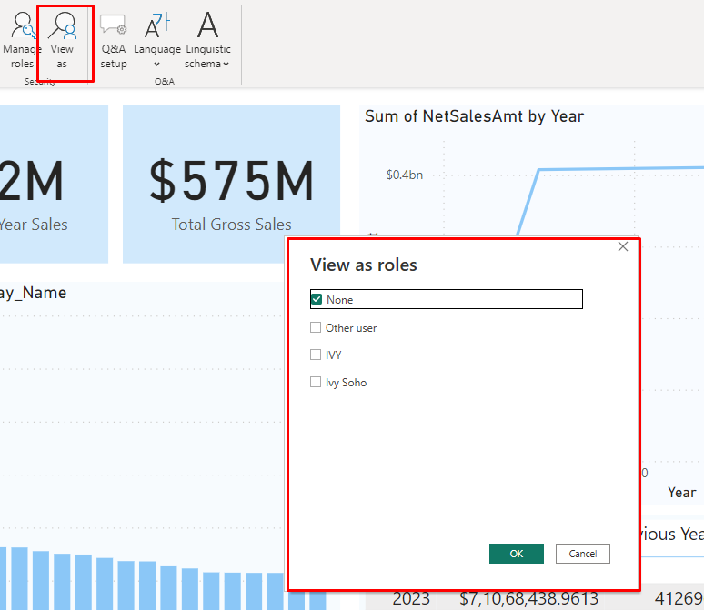

1. Publish your report to power bi service.
2. Go to Power BI Service.
3. Find your report dataset and click on security.

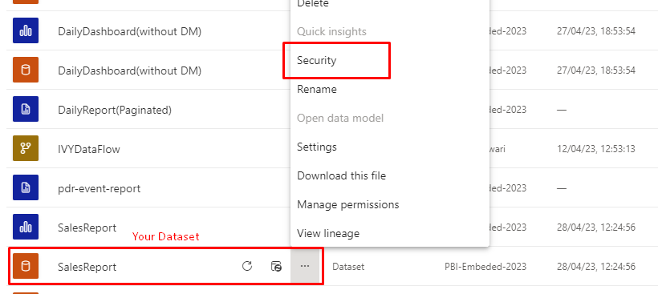

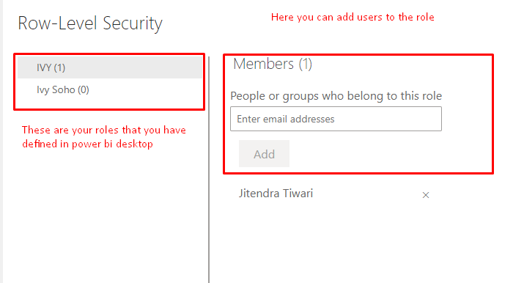

1. If you want to test your report at a particular role .Click on the (…).click on Test as Role.

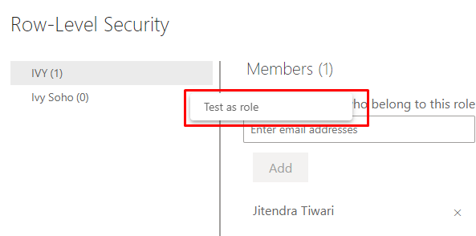

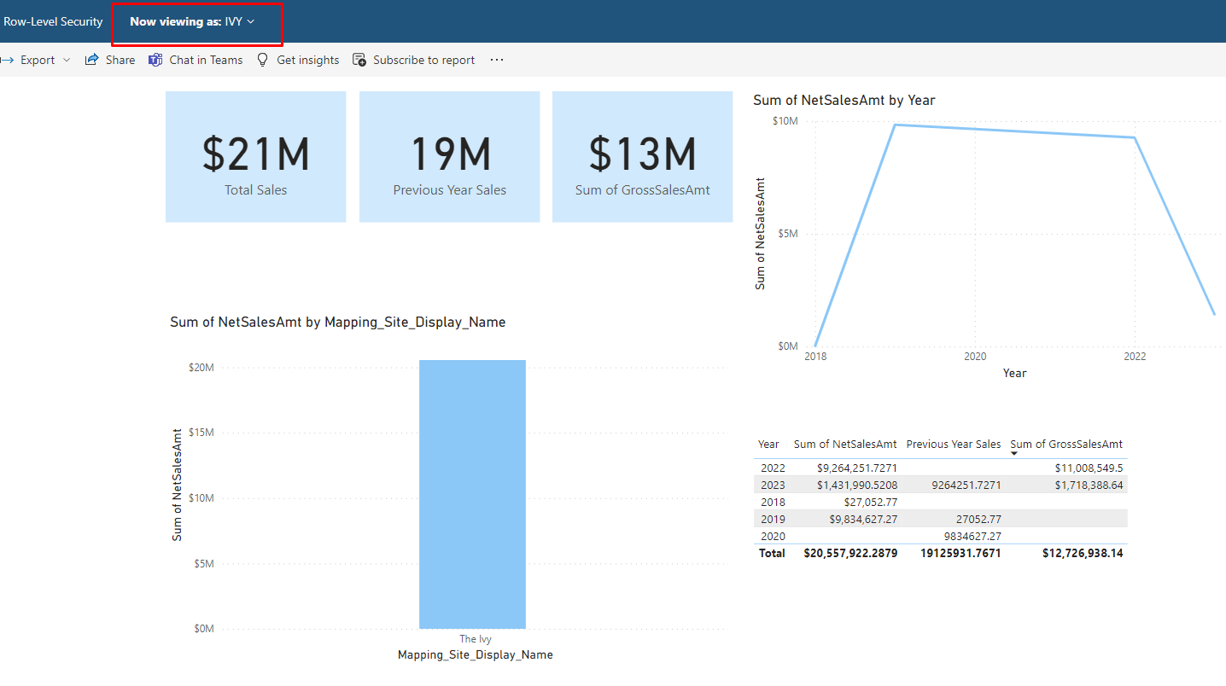

For More Info :

https://learn.microsoft.com/en-us/power-bi/enterprise/service-admin-rls